**NAME: Abdullah Mohsin**

**QUERIES PRACTICE**

**ALL QUERIES CONTENT:**

**TYPES OF DATA LANGUAGES:** 3

**Figure:1.1(ENTITY RELATIONSHIP DIAGRAM)** 3

**RELATIONAL TABLES:** 3

**1.** **MART TABLE:** 3

**2.** **BASKET TABLE:** 3

**3.** **FRUIT TABLE:** 3

• **TUTORIAL:** 4

**Now come to Database languages:** 4

**1.** **DDL (DATA DEFINITION LANGUAGE):** 4

**COMMANDS:** 4

**1.** **CREATE:** 4

**2.** **ALTER:** 4

**11.** **DROP:** 4

**13.** **TRUNCATE:** 4

**15.** **RENAME:** 4

**16.** **COMMENT:** 5

**17.** **USE:** 5

**18.** **PARTITION:** 5

**2.** **DML (Data Manipulation Language):** 5

**COMMANDS:** 5

**1.** **SELECT:** 5

**2.** **INSERT:** 5

**3.** **UPDATE:** 5

**4.** **DELETE:** 5

**5.** **MERGE:** 5

**6.** **CALL:** 5

**7.** **EXPLAIN PLAN:** 5

**8.** **LOCK TABLE:** 5

• **DQL(DATA QUERY LANGUAGE):** 5

**COMMANDS:** 6

**1.** **SELECT:** 6

**2.** **FROM:** 6

**3.** **WHERE:** 6

**4.** **GROUP BY:** 6

**5.** **HAVING:** 6

**6.** **ORDER BY:** 6

**7.** **JOIN:** 6

**8.** **DISTINCT:** 6

**9.** **LIMIT:** 6

**10.** **OFFSET:** 6

**11.** **TOP:** 6

**3.** **DCL (Data Control Language):** 6

**COMMANDS:** 6

**1.** **GRANT:** 6

**2.** **REVOKE:** 6

**4.** **TCL (Transactional Control Language):** 6

**COMMANDS:** 6

**1.** **COMMIT:** 6

**2.** **ROLLBACK:** 6

**3.** **SAVEPOINT:** 6

**4.** **SET TRANSACTION:** 6

• **OBJECTS IN SQL:** 7

**1.** **Tables:** 7

**2.** **Views:** 7

**3.** **Indexes:** 7

**4.** **Schemas:** 7

**5.** **Sequences:** 7

**6.** **Triggers:** 7

**7.** **Stored Procedures:** 7

**8.** **Functions:** 7

**9.** **Constraints (e.g., PRIMARY KEY, FOREIGN KEY, UNIQUE, CHECK, NOT NULL):** 7

**10.** **Synonyms:** 7

**11.** **Users and Roles (for database security management):** 7

• **PL/SQL COMMANDS & OBJECTS IN SQL :** 7

**1.** **Anonymous Blocks:** 7

**2.** **Stored Procedures:** 7

**3.** **Functions:** 8

**4.** **Packages:** 8

**5.** **Triggers:** 8

**6.** **Views:** 8

**7.** **Cursors (Implicit and Explicit):** 8

**8.** **Records:** 8

**9.** **Exceptions:** 8

**10.** **Variables:** 9

**11.** **Collections (Associative Arrays, Nested Tables, Varrays):** 9

# **TYPES OF DATA LANGUAGES:**

There are three types of data models:

1.Data Definition Language

2.Data Manipulation Language

3.Data Control Language

4.Transactional Control Language

EXAMPLES: CONSIDER A ER-DIAGRAM with MART, FRUIT and BASKET:

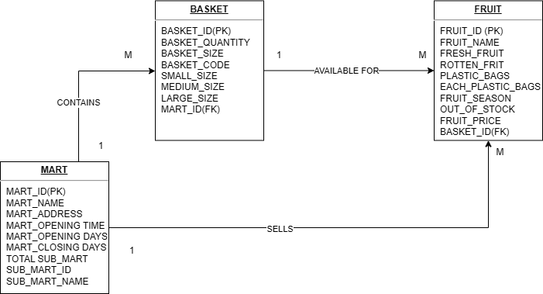

# **Figure:1.1(ENTITY RELATIONSHIP DIAGRAM)**

# **RELATIONAL TABLES:**

# **MART TABLE:**

|  |  |  |  |  |  |  |  |  |
| --- | --- | --- | --- | --- | --- | --- | --- | --- |
| MART-ID(PK) | MART_NAME | MART_  ADDRESS | MART_OPENING_TIME | MART_  OPENING DAYS | MART_CLOSING DAYS | TOTAL_  SUBMART | SUB_  MART_ID | SUB_  MART_NAME |
|  |  |  |  |  |  |  |  |  |
|  |  |  |  |  |  |  |  |  |
|  |  |  |  |  |  |  |  |  |
|  |  |  |  |  |  |  |  |  |

# **BASKET TABLE:**

|  |  |  |  |  |  |  |  |
| --- | --- | --- | --- | --- | --- | --- | --- |
| BASKET-ID(PK) | BASKET_QUANTITY | BASKET_SIZE | BASKET_CODE | SMALL_SIZE | MEDIUM_SIZE | LARGE_SIZE | MART_ID(FK) |
|  |  |  |  |  |  |  |  |
|  |  |  |  |  |  |  |  |
|  |  |  |  |  |  |  |  |
|  |  |  |  |  |  |  |  |

# **FRUIT TABLE:**

|  |  |  |  |  |  |  |  |  |  |
| --- | --- | --- | --- | --- | --- | --- | --- | --- | --- |
| FRUIT-ID(PK) | FRUIT_  NAME | FRESH_  FRUIT | ROTTEN_  FRUIT | PLASTIC_BAGS | EACH_PLASTIC_BAGS | FRUIT_  SEASON | OUT_OF_STOCK | FRUIT_PRICE | BASKET_ID  (FK) |
|  |  |  |  |  |  |  |  |  |  |
|  |  |  |  |  |  |  |  |  |  |
|  |  |  |  |  |  |  |  |  |  |

# **TUTORIAL:**

**W**e are familiar with database, database is the method of storing and managing data in hardware. So, we must need to use a software, this software is known as database management system. Here in this document we are studying SQL, it is relational database management system.

There are three model in order to create a database system:

1.Conceptual Model

2.Representational Model

3.Physical model

You can see in figure 1.1, ER-Diagram has been shown and from that diagram we have created relation schema. We will use above information in order to implement it physically. You can use SQL by downloading it or running queries online.

**CLICK LINK:** [**https://livesql.oracle.com/ords/f?p=590:1000**](https://livesql.oracle.com/ords/f?p=590:1000)

In order to download or use oracle live without any hurdle login in SQL and enjoy writing query, if any doubt contact me :03363736231

# **Now come to Database languages:**

# **DDL (DATA DEFINITION LANGUAGE):**

# **COMMANDS:**

# **CREATE:**

1. --DATABASE LANGUAGE COMMANDS
2. --1.DDL(DATA DEFINITION LANGUAGE)
3. --ENTITIES MART,BASKET,FRUIT
4. CREATE TABLE MART(
5. MART_ID INT  PRIMARY KEY,
6. MART_NAME VARCHAR(10),
7. MART_ADDRESS VARCHAR(30),
8. MART_OPENING_TIME TIMESTAMP,
9. MART_OPENING_DAYS VARCHAR(10),
10. MART_CLOSING_DAYS VARCHAR(10),
11. SUB_MART_ID INT UNIQUE,
12. SUB_MART_NAME VARCHAR(5)
13. );
14. CREATE TABLE BASKET(
15. BASKET_ID INT PRIMARY KEY,
16. BASKET_QUANTITY NUMBER(23,2),
17. BASKET_SIZE INT,
18. SMALL_SIZE INT,
19. MEDIUM_SIZE INT,
20. LARGE_SIZE INT,
21. MART_ID INT,
22. CONSTRAINT FK_MART FOREIGN KEY(MART_ID)REFERENCES MART(MART_ID),
23. CONSTRAINT UNIQUE_BASKET_SIZE UNIQUE(BASKET_SIZE, SMALL_SIZE, MEDIUM_SIZE, LARGE_SIZE)
24. );
25. CREATE TABLE FRUIT(
26. FRUIT_ID INT PRIMARY KEY,
27. FRUIT_NAME VARCHAR(10),
28. FRESH_FRUIT INT,
29. ROTTEN_FRUIT INT,
30. PLASTIC_BAGS NUMBER(10),
31. EACH_PLASTIC_BAGS VARCHAR(1),
32. FRUIT_SEASON VARCHAR(5),
33. OUT_OF_STOCK NUMBER(20),
34. FRUIT_PRICE NUMBER(5,2),
35. BASKET_ID INT,
36. MART_ID INT,
37. CONSTRAINT FK_BASKETS FOREIGN KEY(BASKET_ID)REFERENCES BASKET(BASKET_ID),
38. CONSTRAINT FK_MARTS FOREIGN KEY(MART_ID)REFERENCES MART(MART_ID)
39. );

# **ALTER:**

1. -2.ALTER
2. ALTER TABLE MART ADD MANAGER_NAME VARCHAR(5);--ADD COLUMN
3. ALTER TABLE MART MODIFY MART_NAME VARCHAR(20);--MODIFY COLUMN
4. --CHANGEMENT IN DATATYPE
5. --RENAME TABLE
6. ALTER TABLE MART RENAME COLUMN MART_ID TO MART_NO;
7. --DROP COLUMN
8. ALTER TABLE MART DROP COLUMN MART_NAME;

# **DROP:**

1. DROP TABLE BASKET;

# **TRUNCATE:**

1. TRUNCATE TABLE BASKET;

# **RENAME:**

15.ALTER TABLE BASKET RENAME TO SHOPPING_BASKET;

# **COMMENT:**

16.COMMENT ON TABLE BASKET IS 'This table contains information about different baskets used in the store.';

# **USE:**

17.USE my_database;

# **PARTITION:**

1. CREATE TABLE MART (
2. MART_ID INT PRIMARY KEY,
3. MART_NAME VARCHAR(10),
4. MART_ADDRESS VARCHAR(30),
5. MART_OPENING_TIME TIMESTAMP,
6. MART_OPENING_DAYS VARCHAR(10),
7. MART_CLOSING_DAYS VARCHAR(10),
8. SUB_MART_ID INT UNIQUE,
9. SUB_MART_NAME VARCHAR(5)
10. )
11. PARTITION BY LIST (MART_OPENING_DAYS) (
12. PARTITION p_mon VALUES ('Monday'),
13. PARTITION p_tue VALUES ('Tuesday'),
14. PARTITION p_wed VALUES ('Wednesday'),
15. PARTITION p_thu VALUES ('Thursday'),
16. PARTITION p_fri VALUES ('Friday'),
17. PARTITION p_sat VALUES ('Saturday'),
18. PARTITION p_sun VALUES ('Sunday')
19. );

# **DML (Data Manipulation Language):**

# **COMMANDS:**

# **SELECT:**

SELECT * FROM MART;

# **INSERT:**

INSERT INTO MART (MART_ID, MART_NAME, MART_ADDRESS, MART_OPENING_TIME, MART_OPENING_DAYS, MART_CLOSING_DAYS, SUB_MART_ID, SUB_MART_NAME)

VALUES (2, 'FruitMart', '456 Elm St', TO_TIMESTAMP('2024-01-01 09:00:00', 'YYYY-MM-DD HH24:MI:SS'), 'Monday,Thursday', 'Friday,Saturday', 102, 'SubMart2');

# **UPDATE:**

UPDATE BASKET

SET BASKET_QUANTITY = 150

WHERE BASKET_ID = 1;

# **DELETE:**

DELETE FROM FRUIT

WHERE FRUIT_ID = 1;

# **MERGE:**

MERGE INTO FRUIT f

USING (SELECT 2 AS FRUIT_ID, 'Grapes' AS FRUIT_NAME FROM DUAL) new_fruit

ON (f.FRUIT_ID = new_fruit.FRUIT_ID)

WHEN MATCHED THEN

UPDATE SET f.FRUIT_NAME = new_fruit.FRUIT_NAME

WHEN NOT MATCHED THEN

INSERT (FRUIT_ID, FRUIT_NAME) VALUES (new_fruit.FRUIT_ID, new_fruit.FRUIT_NAME);

# **CALL:**

CALL UpdateFruitStock(1, 100); -- Calls a stored procedure to update stock

# **EXPLAIN PLAN:**

EXPLAIN PLAN FOR

SELECT * FROM MART WHERE MART_ID = 1;

# **LOCK TABLE:**

LOCK TABLE MART IN EXCLUSIVE MODE;

# **DQL(DATA QUERY LANGUAGE):**

Here are the DQL (Data Query Language) commands and clauses:

# **COMMANDS:**

# **SELECT:**

SELECT MART_NAME, MART_ADDRESS FROM MART;

# **FROM:**

SELECT * FROM BASKET;

# **WHERE:**

SELECT FRUIT_NAME FROM FRUIT

WHERE FRUIT_PRICE > 1.00;

# **GROUP BY:**

SELECT MART_ID, COUNT(*) AS FRUIT_COUNT

FROM FRUIT

GROUP BY MART_ID;

# **HAVING:**

SELECT MART_ID, COUNT(*) AS FRUIT_COUNT

FROM FRUIT

GROUP BY MART_ID

HAVING COUNT(*) > 10;

# **ORDER BY:**

SELECT FRUIT_NAME, FRUIT_PRICE

FROM FRUIT

ORDER BY FRUIT_PRICE DESC;

# **JOIN:**

SELECT FRUIT.FRUIT_NAME, BASKET.BASKET_SIZE

FROM FRUIT

INNER JOIN BASKET ON FRUIT.BASKET_ID = BASKET.BASKET_ID;

## **i.INNER JOIN:**

SELECT FRUIT.FRUIT_NAME, BASKET.BASKET_SIZE

FROM FRUIT

INNER JOIN BASKET ON FRUIT.BASKET_ID = BASKET.BASKET_ID;

**ii.LEFT JOIN:**

SELECT FRUIT.FRUIT_NAME, BASKET.BASKET_SIZE

FROM FRUIT

LEFT JOIN BASKET ON FRUIT.BASKET_ID = BASKET.BASKET_ID;

**iii.RIGHT JOIN:**

**SELECT FRUIT.FRUIT_NAME, BASKET.BASKET_SIZE**

**FROM FRUIT**

**RIGHT JOIN BASKET ON FRUIT.BASKET_ID = BASKET.BASKET_ID;**

**iv. FULL JOIN:**

**SELECT FRUIT.FRUIT_NAME, BASKET.BASKET_SIZE**

**FROM FRUIT**

**FULL JOIN BASKET ON FRUIT.BASKET_ID = BASKET.BASKET_ID;**

**v.CROSS JOIN:**

**SELECT FRUIT.FRUIT_NAME, BASKET.BASKET_SIZE**

**FROM FRUIT**

**CROSS JOIN BASKET;**

**Vi .INNER JOIN:**

**SELECT A.FRUIT_NAME AS FRUIT1, B.FRUIT_NAME AS FRUIT2**

**FROM FRUIT A**

**INNER JOIN FRUIT B ON A.BASKET_ID = B.BASKET_ID**

**WHERE A.FRUIT_ID <> B.FRUIT_ID;**

**Vii.NATURAL JOIN:**

**SELECT FRUIT_NAME, BASKET_SIZE**

**FROM FRUIT**

**NATURAL JOIN BASKET;**

**Viii.ANTI JOIN:**

**SELECT FRUIT_NAME**

**FROM FRUIT**

**WHERE BASKET_ID NOT IN (SELECT BASKET_ID FROM BASKET);**

**ix.SEMI JOIN:**

**SELECT FRUIT_NAME**

**FROM FRUIT**

**WHERE EXISTS (SELECT 1 FROM BASKET WHERE FRUIT.BASKET_ID = BASKET.BASKET_ID);**

# **DISTINCT:**

SELECT DISTINCT FRUIT_NAME

FROM FRUIT;

# **LIMIT:**

SELECT * FROM FRUIT

LIMIT 5;

# **OFFSET:**

SELECT * FROM FRUIT

LIMIT 5 OFFSET 10;

# **TOP:**

SELECT TOP 5 * FROM FRUIT;

# **DCL (Data Control Language):**

# **COMMANDS:**

# **GRANT:**

GRANT SELECT, INSERT ON MART TO user_name;

# **REVOKE:**

REVOKE SELECT, INSERT ON MART FROM user_name;

# **TCL (Transactional Control Language):**

# **COMMANDS:**

# **COMMIT:**

UPDATE BASKET

SET BASKET_QUANTITY = 200

WHERE BASKET_ID = 1;

COMMIT;

# **ROLLBACK:**

UPDATE BASKET

SET BASKET_QUANTITY = 200

WHERE BASKET_ID = 1;

ROLLBACK;

# **SAVEPOINT:**

SAVEPOINT sp1;

UPDATE BASKET

SET BASKET_QUANTITY = 200

WHERE BASKET_ID = 1;

SAVEPOINT sp2;

UPDATE BASKET

SET BASKET_QUANTITY = 300

WHERE BASKET_ID = 2;

ROLLBACK TO sp1;

# **SET TRANSACTION:**

SET TRANSACTION ISOLATION LEVEL SERIALIZABLE;

UPDATE MART

SET MART_ADDRESS = '789 Oak St'

WHERE MART_ID = 1;

## **OBJECTS IN SQL:**

These are objects of SQL:

# **Tables:**

CREATE TABLE Employees (

Employee ID INT PRIMARY KEY,

Name VARCHAR (50) NOT NULL,

Department VARCHAR (50),

Salary DECIMAL (10, 2)

);

# **Views:**

CREATE VIEW HighSalaryEmployees AS

SELECT Name, Salary

FROM Employees

WHERE Salary > 50000;

# **Indexes:**

CREATE INDEX idx_salary ON Employees(Salary);

# **Schemas:**

CREATE SCHEMA Sales AUTHORIZATION sales_manager;

# **Sequences:**

CREATE SEQUENCE emp_seq

START WITH 1

INCREMENT BY 1;

# **Triggers:**

CREATE TRIGGER trg_salary_check

BEFORE INSERT ON Employees

FOR EACH ROW

WHEN (NEW.Salary < 0)

BEGIN

RAISE_APPLICATION_ERROR(-20001, 'Salary cannot be negative.');

END;

# **Stored Procedures:**

CREATE PROCEDURE UpdateSalary (emp_id INT, new_salary DECIMAL)

AS

BEGIN

UPDATE Employees

SET Salary = new_salary

WHERE Employee_ID = emp_id;

END;

# **Functions:**

CREATE FUNCTION CalculateBonus (salary DECIMAL)

RETURNS DECIMAL

AS

BEGIN

RETURN salary * 0.1;

END;

# **Constraints (e.g., PRIMARY KEY, FOREIGN KEY, UNIQUE, CHECK, NOT NULL):**

CREATE TABLE Departments (

Dept_ID INT PRIMARY KEY,

Dept_Name VARCHAR(50) NOT NULL,

Manager_ID INT UNIQUE,

CONSTRAINT chk_name CHECK (Dept_Name != '')

);

# **Synonyms:**

CREATE SYNONYM EmpView FOR HighSalaryEmployees;

# **Users and Roles (for database security management):**

CREATE USER john IDENTIFIED BY password123;

GRANT CONNECT, CREATE TABLE TO john;

CREATE ROLE SalesRole;

GRANT SELECT, INSERT ON Employees TO SalesRole;

GRANT SalesRole TO john;

# **PL/SQL COMMANDS & OBJECTS IN SQL :**

These are objects of PL/SQL:

# **Anonymous Blocks:**

BEGIN

DBMS_OUTPUT.PUT_LINE('Hello, PL/SQL!');

END;

# **Stored Procedures:**

CREATE PROCEDURE UpdateEmployeeSalary (emp_id INT, increment DECIMAL)

AS

BEGIN

UPDATE Employees

SET Salary = Salary + increment

WHERE Employee_ID = emp_id;

END;

# **Functions:**

CREATE FUNCTION GetTotalSalary

RETURN DECIMAL

AS

total_salary DECIMAL;

BEGIN

SELECT SUM(Salary) INTO total_salary FROM Employees;

RETURN total_salary;

END;

# **Packages:**

CREATE PACKAGE EmployeePackage AS

PROCEDURE UpdateEmployeeSalary(emp_id INT, increment DECIMAL);

FUNCTION GetEmployeeCount RETURN INT;

END EmployeePackage;

CREATE PACKAGE BODY EmployeePackage AS

PROCEDURE UpdateEmployeeSalary(emp_id INT, increment DECIMAL) AS

BEGIN

UPDATE Employees

SET Salary = Salary + increment

WHERE Employee_ID = emp_id;

END;

FUNCTION GetEmployeeCount RETURN INT AS

emp_count INT;

BEGIN

SELECT COUNT(*) INTO emp_count FROM Employees;

RETURN emp_count;

END;

END EmployeePackage;

# **Triggers:**

CREATE TRIGGER trg_before_insert

BEFORE INSERT ON Employees

FOR EACH ROW

BEGIN

IF :NEW.Salary < 0 THEN

RAISE_APPLICATION_ERROR(-20001, 'Salary cannot be negative.');

END IF;

END;

# **Views:**

CREATE VIEW ActiveEmployees AS

SELECT Name, Department, Salary

FROM Employees

WHERE Salary > 0;

# **Cursors (Implicit and Explicit):**

BEGIN

SELECT Salary INTO total_salary FROM Employees WHERE Employee_ID = 1;

DBMS_OUTPUT.PUT_LINE('Total Salary: ' || total_salary);

END;

DECLARE

CURSOR emp_cursor IS SELECT Name, Salary FROM Employees;

emp_name Employees.Name%TYPE;

emp_salary Employees.Salary%TYPE;

BEGIN

OPEN emp_cursor;

LOOP

FETCH emp_cursor INTO emp_name, emp_salary;

EXIT WHEN emp_cursor%NOTFOUND;

DBMS_OUTPUT.PUT_LINE(emp_name || ': ' || emp_salary);

END LOOP;

CLOSE emp_cursor;

END;

# **Records:**

DECLARE

emp_rec Employees%ROWTYPE;

BEGIN

SELECT * INTO emp_rec FROM Employees WHERE Employee_ID = 1;

DBMS_OUTPUT.PUT_LINE('Name: ' || emp_rec.Name || ', Salary: ' || emp_rec.Salary);

END;

# **Exceptions:**

BEGIN

UPDATE Employees SET Salary = -1 WHERE Employee_ID = 1;

EXCEPTION

WHEN OTHERS THEN

DBMS_OUTPUT.PUT_LINE('An error occurred: ' || SQLERRM);

END;

# **Variables:**

DECLARE

emp_name VARCHAR2(50);

emp_salary DECIMAL(10, 2);

BEGIN

emp_name := 'John Doe';

emp_salary := 50000;

DBMS_OUTPUT.PUT_LINE(emp_name || ': ' || emp_salary);

END;

# **Collections (Associative Arrays, Nested Tables, Varrays):**

DECLARE

TYPE salary_array IS TABLE OF DECIMAL INDEX BY PLS_INTEGER;

salaries salary_array;

BEGIN

salaries(1) := 50000;

salaries(2) := 60000;

DBMS_OUTPUT.PUT_LINE('First Salary: ' || salaries(1));

END;

--NESTED TABLE

DECLARE

TYPE salary_table IS TABLE OF DECIMAL;

salaries salary_table := salary_table(50000, 60000, 70000);

BEGIN

FOR i IN 1..salaries.COUNT LOOP

DBMS_OUTPUT.PUT_LINE('Salary ' || i || ': ' || salaries(i));

END LOOP;

END;

DECLARE

TYPE salary_varray IS VARRAY(3) OF DECIMAL;

salaries salary_varray := salary_varray(50000, 60000, 70000);

BEGIN

FOR i IN 1..salaries.COUNT LOOP

DBMS_OUTPUT.PUT_LINE('Salary ' || i || ': ' || salaries(i));

END LOOP;

END;

# **NORMALIZATION:**

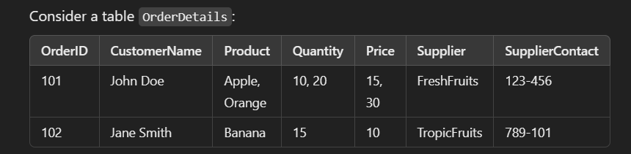

1NF:

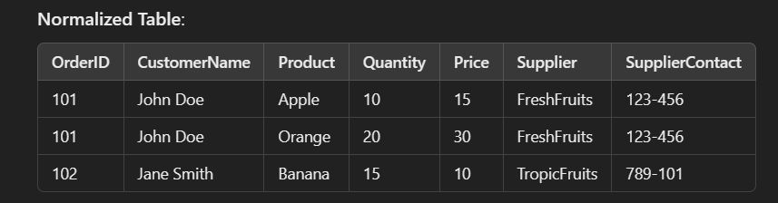

2NF

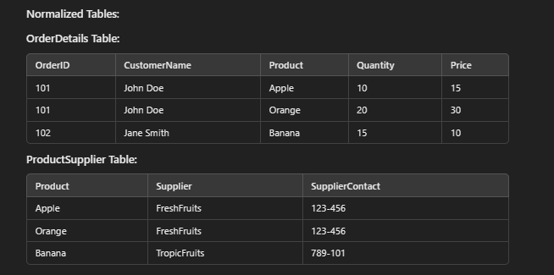

3NF

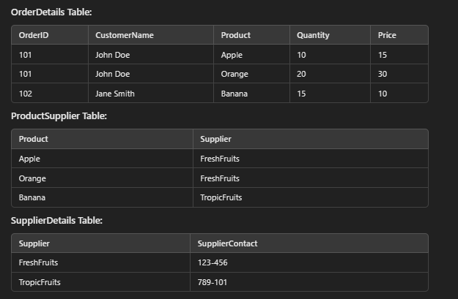

ANS:

1NF:

CREATE TABLE OrderDetails_1NF (

OrderID INT,

CustomerName VARCHAR(50),

Product VARCHAR(50),

Quantity INT,

Price DECIMAL(10, 2),

Supplier VARCHAR(50),

SupplierContact VARCHAR(20)

);

INSERT INTO OrderDetails_1NF

VALUES

(101, 'John Doe', 'Apple', 10, 15, 'FreshFruits', '123-456'),

(101, 'John Doe', 'Orange', 20, 30, 'FreshFruits', '123-456'),

(102, 'Jane Smith', 'Banana', 15, 10, 'TropicFruits', '789-101');

2NF:

CREATE TABLE OrderDetails_2NF (

OrderID INT,

CustomerName VARCHAR(50),

Product VARCHAR(50),

Quantity INT,

Price DECIMAL(10, 2),

PRIMARY KEY (OrderID, Product)

);

CREATE TABLE ProductSupplier (

Product VARCHAR(50) PRIMARY KEY,

Supplier VARCHAR(50),

SupplierContact VARCHAR(20)

);

INSERT INTO OrderDetails_2NF

VALUES

(101, 'John Doe', 'Apple', 10, 15),

(101, 'John Doe', 'Orange', 20, 30),

(102, 'Jane Smith', 'Banana', 15, 10);

INSERT INTO ProductSupplier

VALUES

('Apple', 'FreshFruits', '123-456'),

('Orange', 'FreshFruits', '123-456'),

('Banana', 'TropicFruits', '789-101');

**3NF**

CREATE TABLE SupplierDetails (

Supplier VARCHAR(50) PRIMARY KEY,

SupplierContact VARCHAR(20)

);

INSERT INTO SupplierDetails

VALUES

('FreshFruits', '123-456'),

('TropicFruits', '789-101');

ALTER TABLE ProductSupplier

DROP COLUMN SupplierContact;

INSERT INTO ProductSupplier

VALUES

('Apple', 'FreshFruits'),

('Orange', 'FreshFruits'),

('Banana', 'TropicFruits');

